1)The TOP 5 of CTR

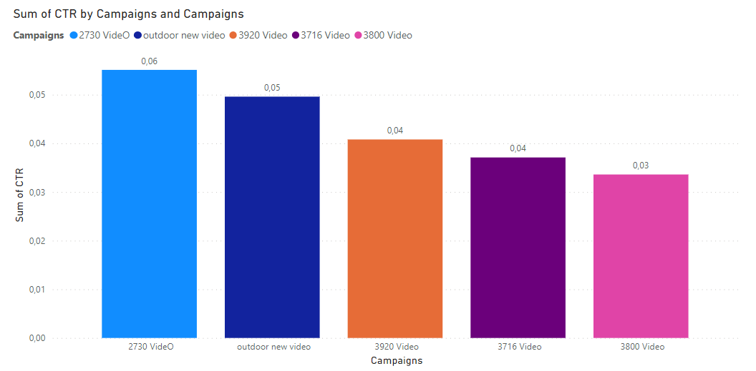

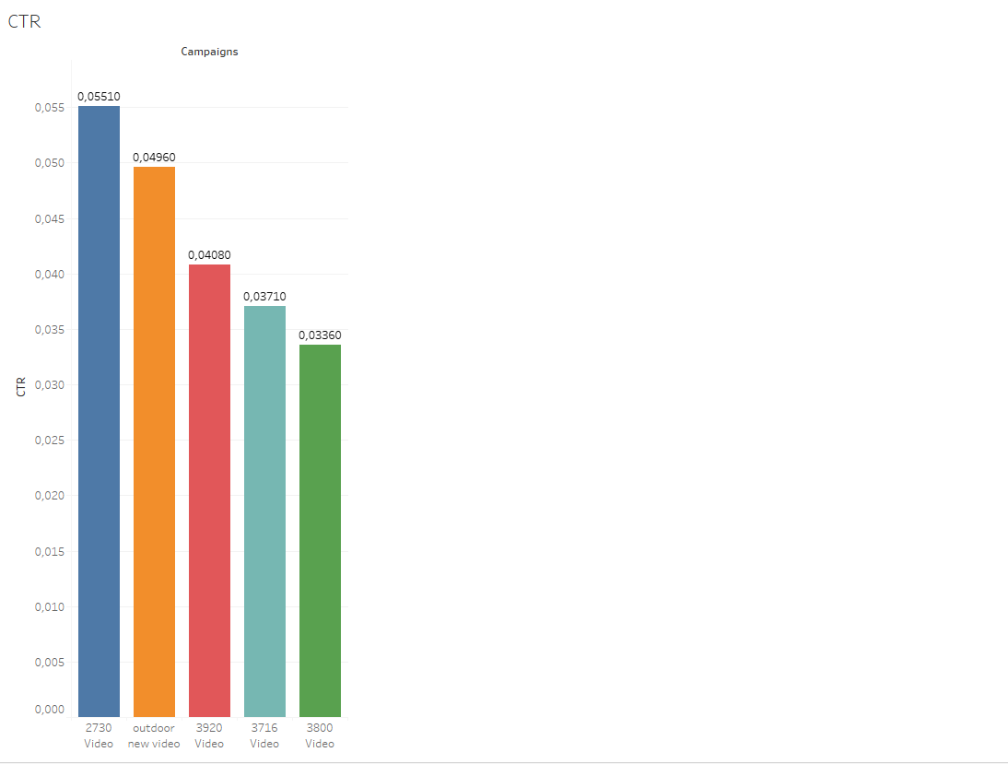

As it is seen above, the highest number of CTR belongs to ‘2730 video’ campaign among of the Amazon Campaigns. The graph also mentions another top 5 CTR rates of campaigns.

**2) The relation between Amazon ads and Sales**

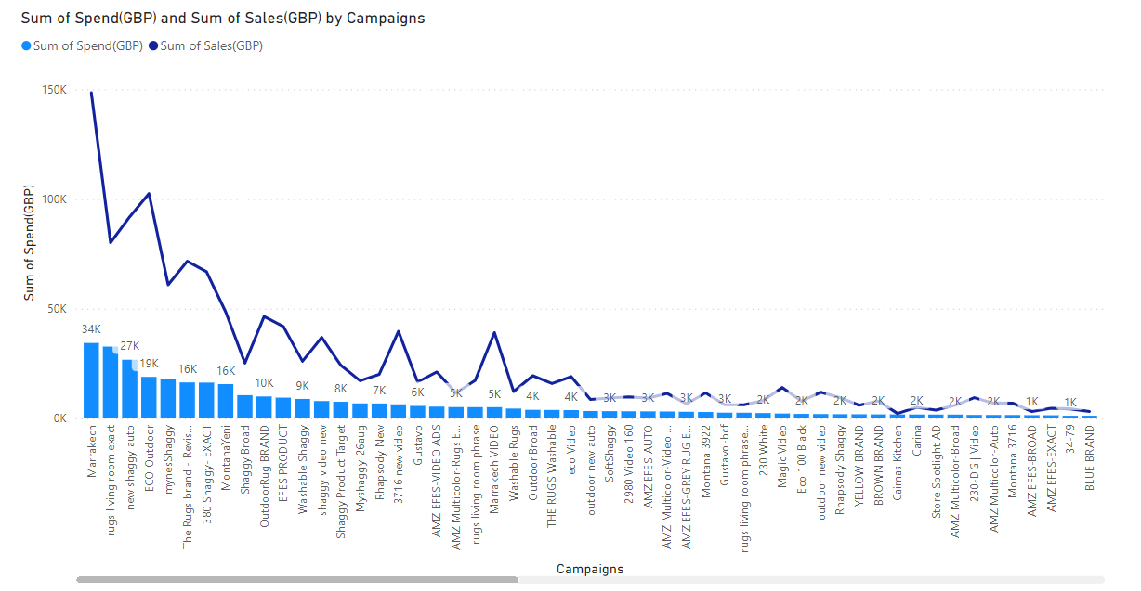

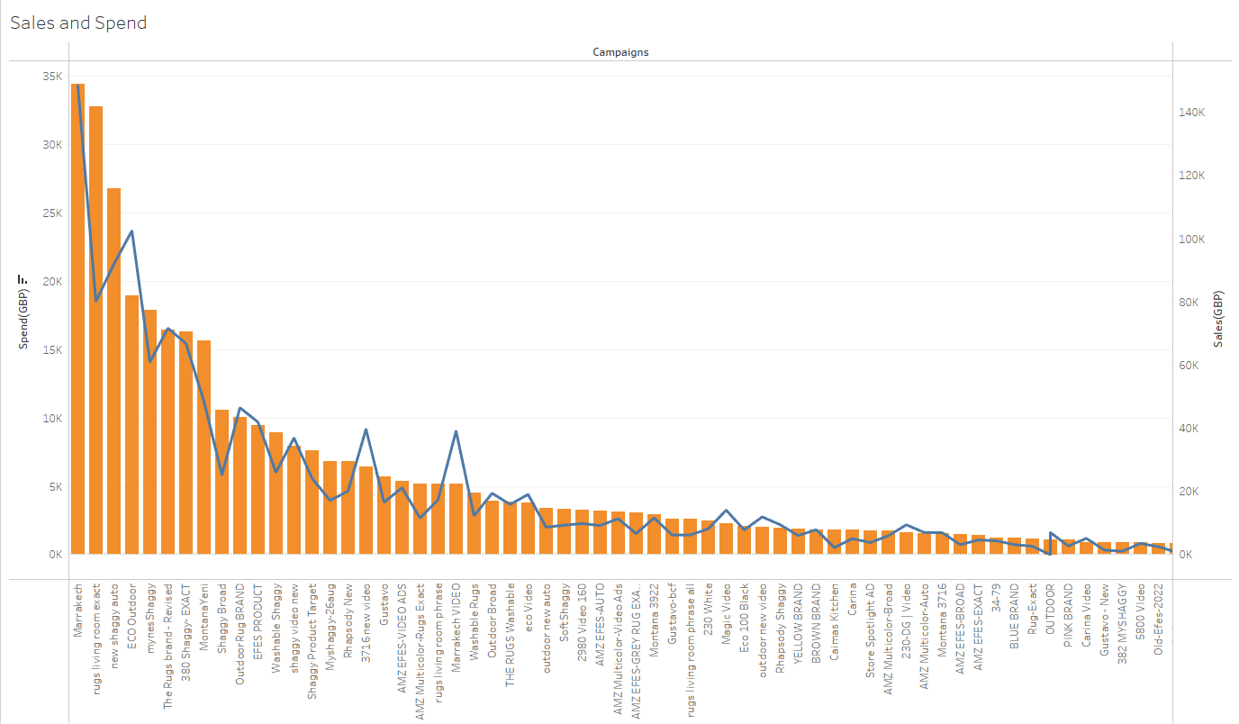

The graph above it is aimed to measure the statistical relation between sales and the amount which spent for the ads.

For almost 34.000$ was spent for the Marrakech campaign. On the other hand, sales of ‘Marrakech Campaign’ approximately 150 thousand dollars were achieved. Referring to this chart, it can be said that there is a relatively positive relationship between advertising expenditure and income.

**3)The Relation between CPC and Income**

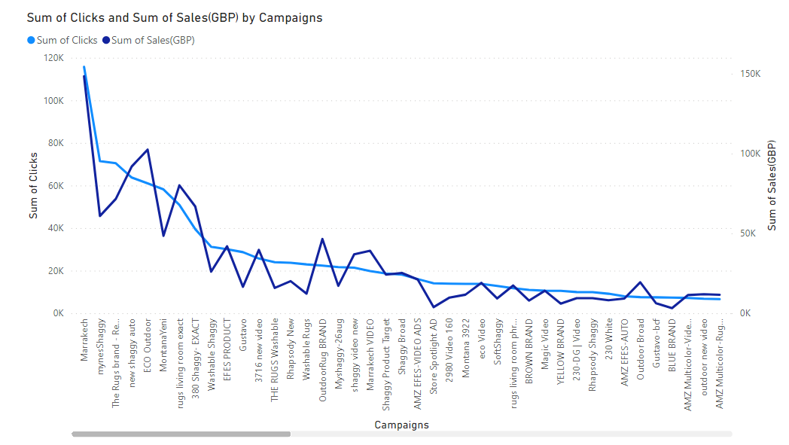

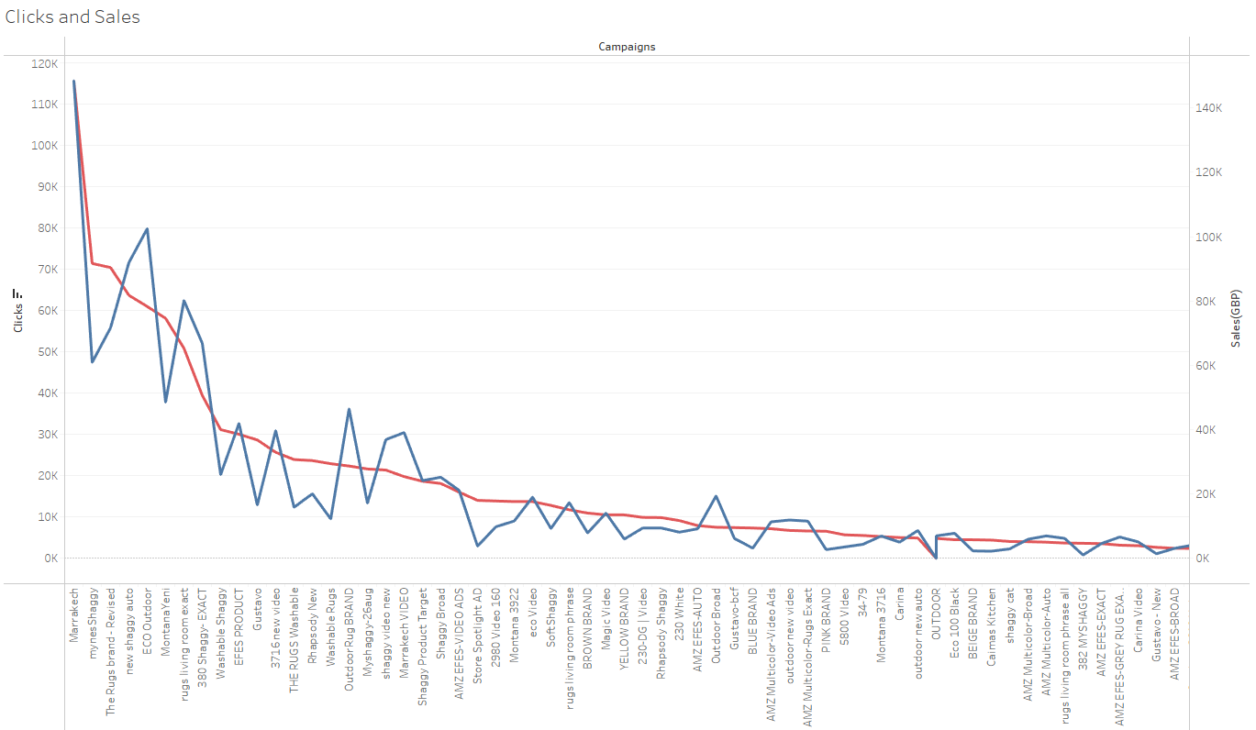

The graph above tell us the relation between CPC and Income at the end of Amazon campaigns. From this graph the idea can come out, that the relation between CPC and Income of a campaign relative positive is.

4)The Relation between CTR and Sales(GBP)

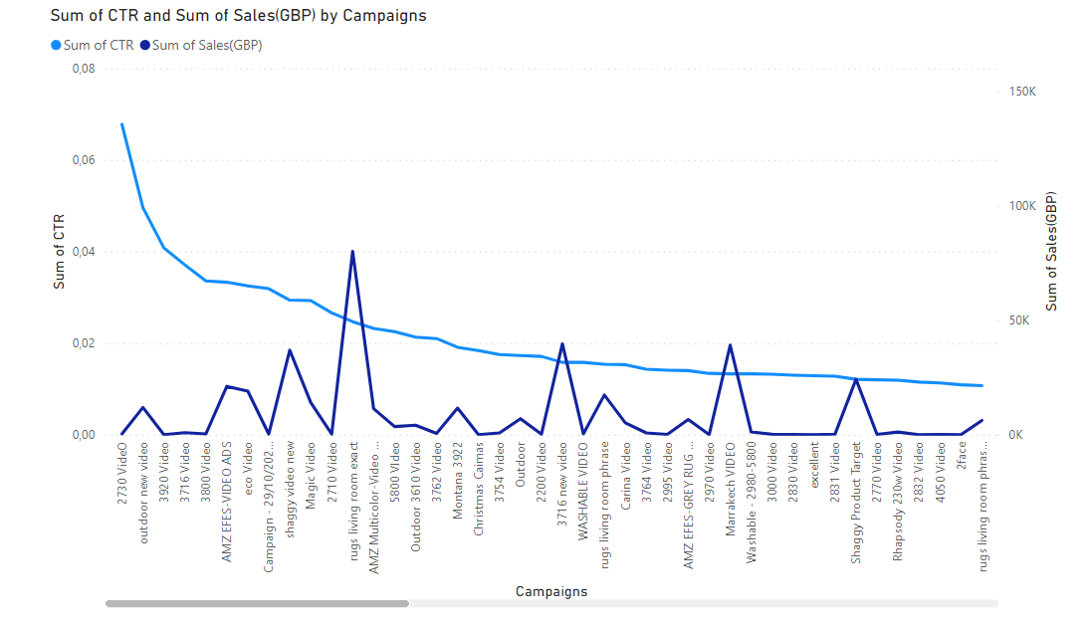

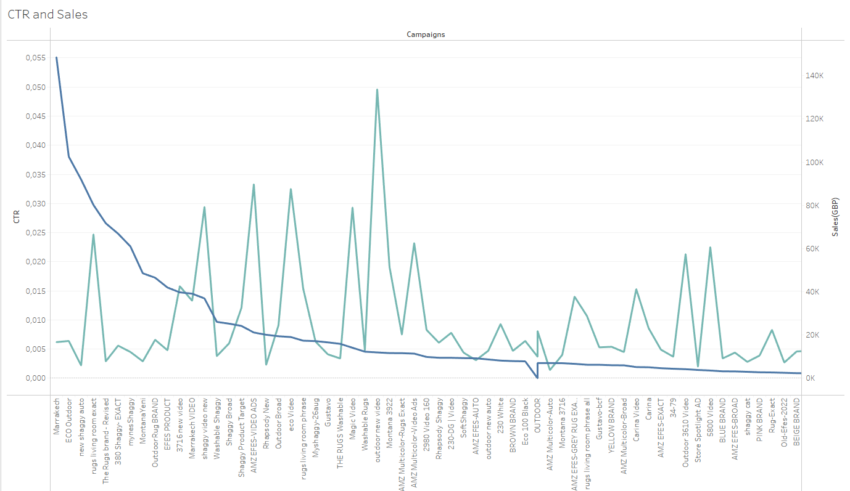

It can be easily said that the relation between CTR and Sales(GBP) is neither positive nor negative . Even if the campaign ‘2730’ have the highest CTR rate, but it has almost 360 pounds sales amount. In compare to ‘Rugs Living room campaign’ despite it has lower CTR rate but almost 80K pounds sales amount.

**5)The relation between Spent(GBP) and CTR(clicks)**

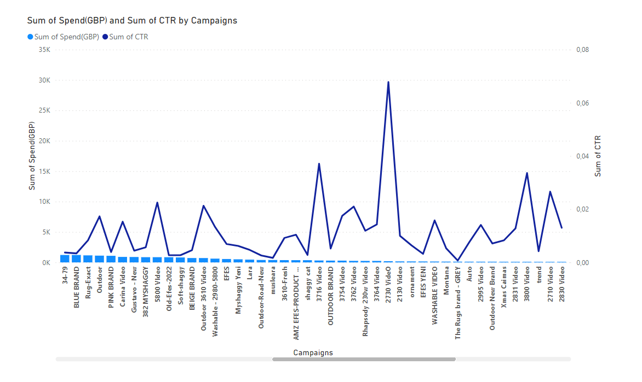

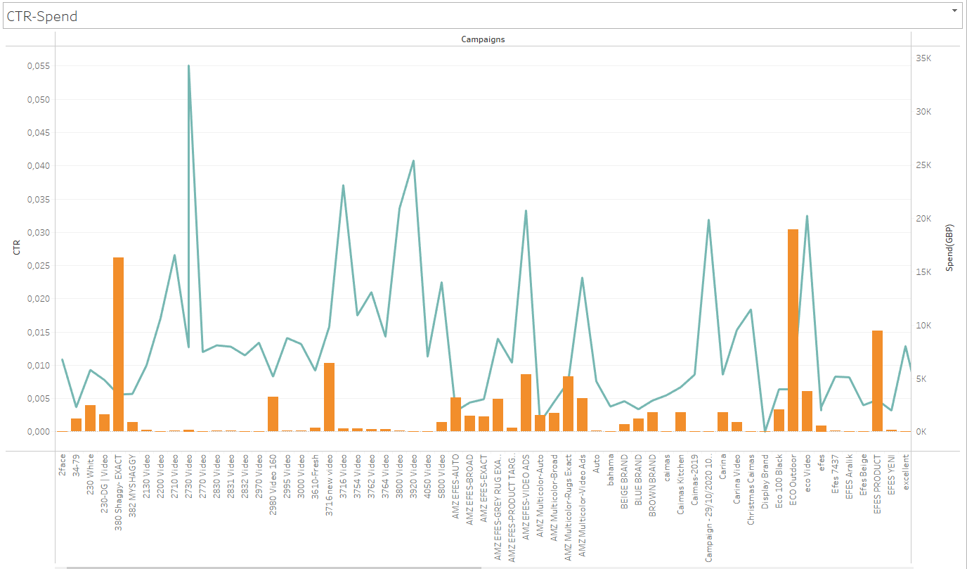

As can be seen from this graph, it can be said that a high CTR ratio reduces advertising expenditures. While the CTR value of the campaign 2730 is 0.07, the total amount spent on the advertisement is seen as 193 pounds.

6)The Relation between Sales(GBP) and Clicks

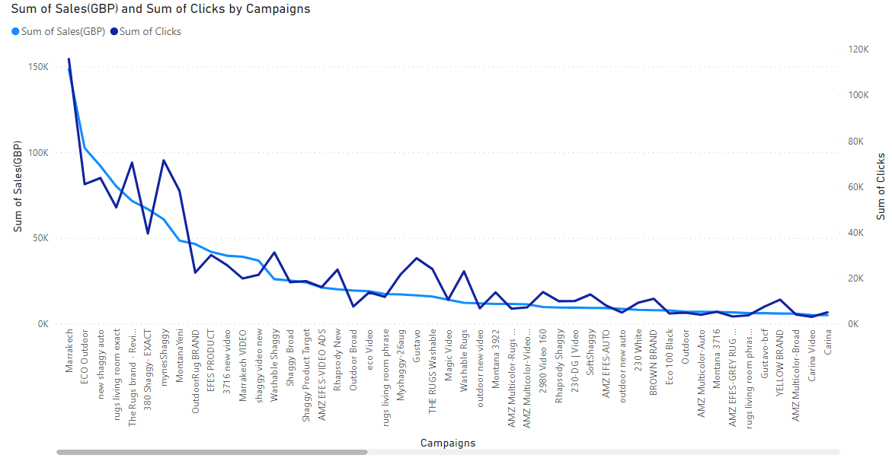

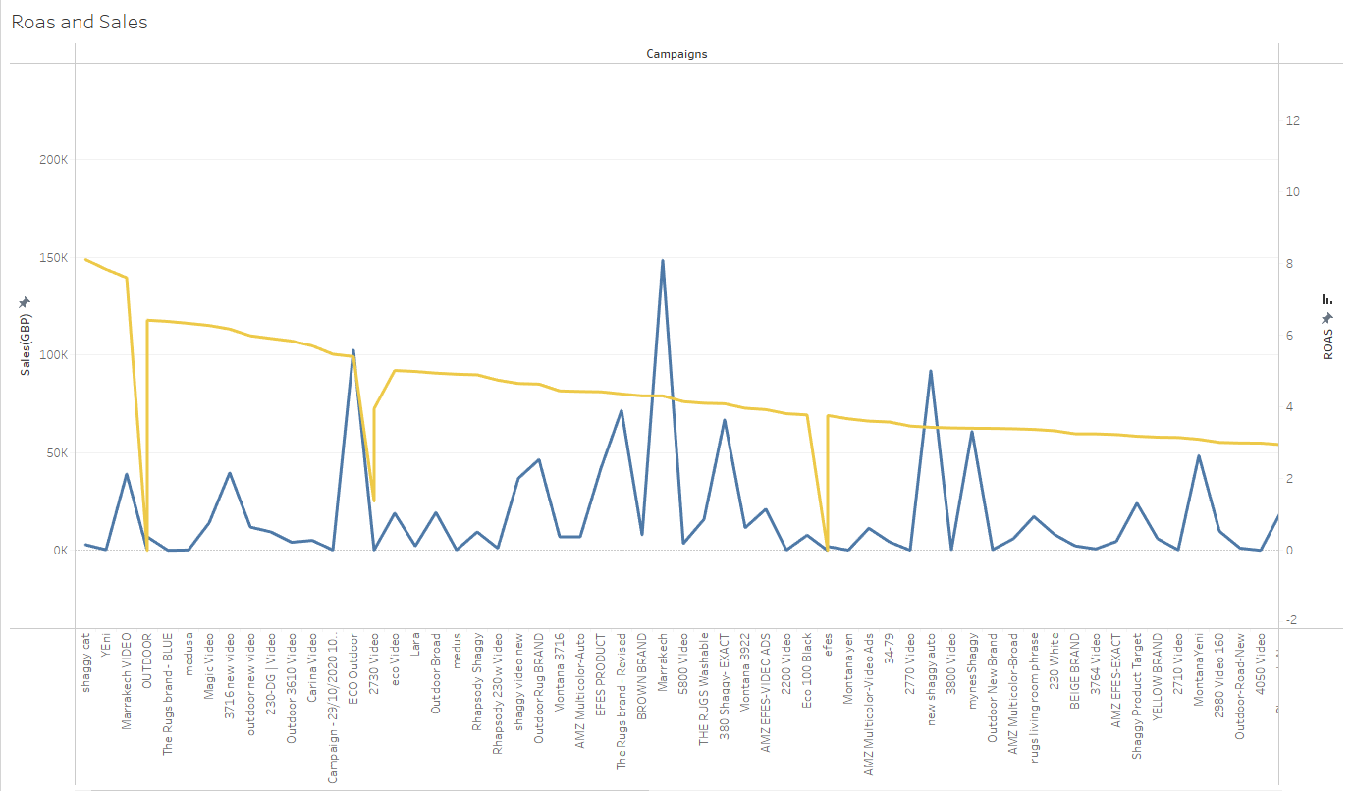

The result to be drawn from the chart above will be that the product with more clicks will sell more. Therefore, it can be said that there is a positive relationship between clicks and revenues.